References

Guttmacher Institute. (2020). Pregnancies, Births and Abortions in the United States: National and State Trends by Age. Osf.io. Retrieved from https://osf.io/kthnf/

Norris, A., Bessett, D., Steinberg, J. R., Kavanaugh, M. L., Silvia De Zordo, & Becker, D. (2011). Abortion Stigma: A Reconceptualization of Constituents, Causes, and Consequences. Women’s Health Issues, 21(3), S49–S54. https://doi.org/10.1016/j.whi.2011.02.010

Sanger, C. (2017). About abortion : terminating pregnancy in twenty-first-century America. Cambridge, Massachusetts: The Belknap Press Of Harvard University Press.

Appendix A

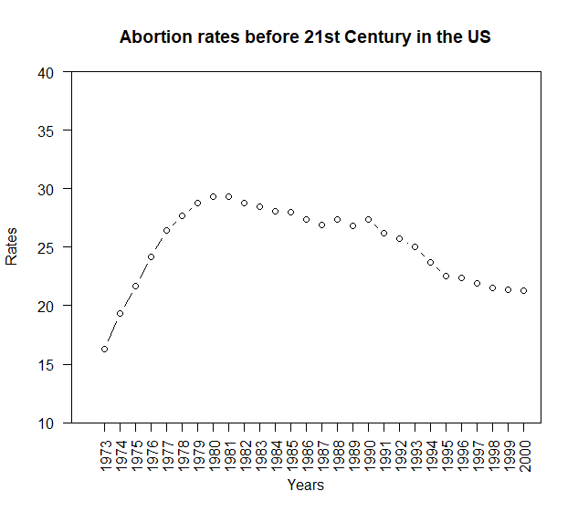

Appendix B

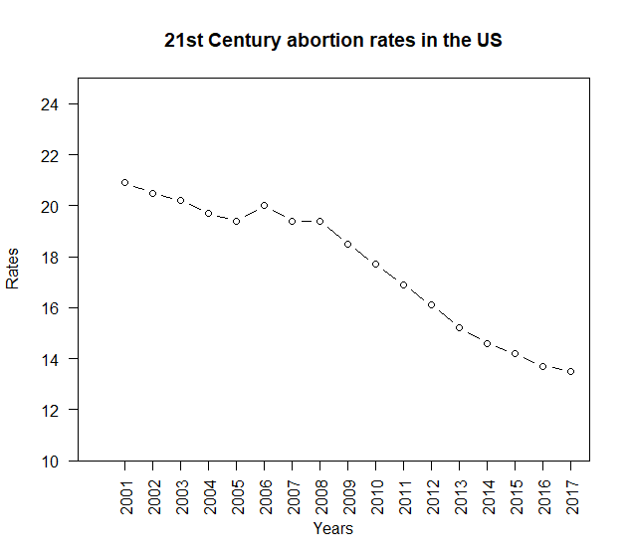

Appendix C

